

**A Project Report of Computer Networks on Campus Network Design**

By

**Hifza Khalid** SU92-BSSEM-F22-202

Under the Guidance of

**Sir Rasikh Ali** Dept. of SE

**ABSTRACT**

Computer networks have a significant impact on the working of an organization. Universities depend on the proper functioning and analysis of their networks for education, administration, communication, elibrary, automation, etc. An efficient network is essential to facilitate the systematic and cost-efficient transfer of information in an organization in the form of messages, files, and resources. The project provides insights into various concepts such as topology design, IP address configuration, and how to send information in the form of packets to the wireless networks of different areas of a campus.

The aim of this project is to design the topology of the university network using the software Cisco Packet Tracer with the implementation of wired networking systems. This campus network consists of the following devices:

1. Router
2. Switches
3. Web Server
4. FTP Server
5. PCs
6. Printer

**Introduction:**

The word “digital” is very significant in today’s world, with an increase in the development of technology the entire world is moving towards the digital era. The educational institution plays an important role in this digitalization; hence the campus should adapt to digital means of networking as well and become a “digital campus”. Going wireless plays an important role in this digitalization. The wireless network makes the connection easy with a reduction in the use of wires or cables. A wired connection makes it difficult to keep track of all the devices and to manage the cable connection, which is not only chaotic but also challenging to handle. Campus networking via wireless connection becomes an important part of campus life and provides the main way for teachers and students to access educational resources, which gives an important platform to exchange information. As laptops and intelligent terminals are widely used, demand for access to information anytime and anywhere has become more and more urgent, but traditional cable networks cannot meet this requirement. Then wireless network construction becomes necessary and essential. The wireless network provides an efficient way to explore the internet with a mobile terminal for teachers and students regardless of cables and places. With the development of network and communication technology, cable networks on a university campus bring much convenience for teaching and research work. But for mobility and flexibility, it has obvious shortcomings. A wireless network can overcome these drawbacks and has been applied to the university campus

**NETWORK LAYOUT BRIEF:**

Suppose there is a large university which has two campuses situated 20 miles apart. The university’s students and staff are distributed into four faculties; these include the faculties of health and science; Business; Engineering/Computing and Art/Design. Each member of staff has a PC, and students have access to PCs in the labs.

**Requirements:**

• Create a network topology with the main components to support the following

o *Main Campus*

* **Building A:** Administrative staff in the department of management, HR and Finance. The admin staff PCs are distributed in the building offices, and it is expected that they will share some networking equipment. The faculty of Business is also situated in this building.
* **Building B**: Faculty of Engineering and Computing and Faculty of Art and Design.
* **Building C:** Student’s lab and IT department. The IT department hosts the university web server and other server
* There is also an email sever hosted externally on the

cloud

o *Smaller Campus*

▪ Faculty of Health and Science(staff and student’s lab are situated on different floors)

You will be expected to configure the core devices and few end devices to provide end-to-end connectivity and access to the internal servers and the external servers

* Each department/faculty is expected to be its own separate IP

network

* The switches should be configured with appropriate VLANs and

security settings

**Tasks:**

**Task 1:** Your task i s to plan, design and prototype the network

topology for the campus network using Cisco Paket Tracer

**Task 2:** Configure in Packet Tracer with appropriate settings to achieve the connectivity and functionalities specified in the requirements

**Task 3:** Produce a report including evaluation of your proposed network design and appraisal of your work. Your evaluation should

include

**Technologies Implemented**

1.Creating a network topology using Cisco Packet Tracer.

1. Hierarchical Network Design
2. Connecting Networking devices with Correct cabling.
3. Creating VLANs and assigning ports VLAN numbers.
4. Subnetting and IP Addressing.
5. Configuring Inter-VLAN Routing (Router on a stick) 7. Configuring DHCP Server (Router as the DHCP Server).
6. Configuring SSH for secure Remote access.
7. Configuring RIPv2 as the routing protocol.
8. Configuring switchport security or Port-Security on the switches.
9. Host Device Configurations.
10. Test and Verifying Network Communication.

**LITERATURE REVIEW**

* + ***What is a Packet Tracer?***

Packet Tracer is a cross-platform visual simulation tool designed by Cisco Systems that allows users to create network topologies and imitate modern computer networks. The software allows users to simulate the configuration of Cisco routers and switches using a simulated command-line interface.

Packet Tracer makes use of a drag-and-drop user interface, allowing users to add and remove simulated network devices as they see fit. The software is mainly focused on Certified Cisco Network Associate Academy students as an educational tool for helping them learn fundamental CCNA concepts. Previously students enrolled in a CCNA Academy program could freely download and

use the tool free of charge for educational use

* + **Router**

A router is a device like a switch that routes data packets based on their IP addresses. The router is mainly a Network Layer device.

Routers normally connect LANs and WANs together and have a dynamically updated routing table based on which they make decisions on routing the data packets. Router divides broadcast domains of hosts connected through it.

* **Switch** 
  1. network switch (also called switching hub, bridging hub, officially MAC bridge is networking hardware that connects devices on a computer network by using packet switching to receive and forward data to the destination device. A network switch is a multiport network bridge that uses MAC addresses to forward data at the data link layer (layer 2) of the OSI model. Some switches can also forward data at the network layer (layer 3) by additionally incorporating routing functionality. Such switches are commonly known as layer-3 switches or multilayer switches
* **Network Packet**

A network packet is a formatted unit of data carried by a packet switched network. A packet consists of control information and user data, which is also known as the payload.

* **Server** 
  1. server is a computer or system that provides resources, data, services, or programs to other computers, known as clients, over a network. In theory, whenever computers share resources with client machines, they are considered servers. There are many types of servers, including web servers, mail servers, and virtual servers.

## ➢ DNS Server

DNS stands for Domain Name System servers which are application servers that provide a human-friendly naming method to the user computers to make IP addresses readable by users. The DNS system is a widely distributed database of names and other DNS servers, each of which can be used to request an otherwise unknown computer name. When a user needs the address of a system, it sends a DNS request with the name of the desired resource to a DNS server. The DNS server responds with the necessary IP address from its table of names

* ***WEB Server***

One of the widely used servers in today’s market is a web server. A web server is a special kind of application server that hosts programs and data requested by users across the Internet or an intranet. Web servers respond to requests from browsers running on client computers for web pages, or other web-based services.

* ***EMAIL Server***

An e-mail server is a server that handles and delivers e-mail over a network, using standard email protocols. For example, the SMTP protocol sends messages and handles outgoing mail requests. The POP3 protocol receives messages and is used to process incoming mail. When you log on to a mail server using a webmail interface or email client, these protocols handle all the connections behind the

scenes.

* + **Printer** 
    1. printer is a device that accepts text and graphics output from acomputer, and it transfers this information to paper, sheets. Printers can print any information that has been passed to it, whether it be Text, Numbers or Images. It depends on the type of printer that what quality or color the printed matter would be.

* + **Wireless Network** 
    1. wireless network broadcasts an access signal to the workstations or PCs. This enables mobility among laptops, tablets, and PCs from room to room while maintaining a firm network connection continuously. A wireless network also presents additional security requirements.

* + **Ethernet**

This is the backbone of our network. It consists of the cabling and is typically able to transfer data at a rate of 100mb/s. It is a system for connecting several computer systems to form a local area network, with protocols to control the passing of information and to avoid simultaneous transmission by two or more systems. Among the different types of ethernet, we have used Gigabit Ethernet, which is a type of Ethernet network capable of transferring data at a rate of 1000 Mbps and fast Ethernet is a type of Ethernet network that can transfer data at a rate of 100 Mbps.

* + **VLANs**

A **virtual local area network** (**VLAN**) is any [broadcast domain](https://en.wikipedia.org/wiki/Broadcast_domain) that is [partitioned](https://en.wikipedia.org/wiki/Network_segmentation) and isolated in a [computer network](https://en.wikipedia.org/wiki/Computer_network) at the [data link layer](https://en.wikipedia.org/wiki/Data_link_layer) [(OSI layer 2)](https://en.wikipedia.org/wiki/OSI_model#Layer_2:_Data_link_layer). In this context, [virtual](https://en.wikipedia.org/wiki/Virtualization) refers to a physical object recreated and altered by additional logic, within the [local area network.](https://en.wikipedia.org/wiki/Local_area_network) VLANs work by applying tags to network frames and handling these tags in networking systems – creating the appearance and functionality of [network traffic](https://en.wikipedia.org/wiki/Network_traffic) that is physically on a single network but acts as if it is split between separate networks. In this way, VLANs can keep network applications separate despite being connected to the same physical network, and without requiring multiple sets of cabling and networking devices to be deployed.

* + **Computing Device**

8 Computing devices are the electronic devices that take user inputs, process the inputs, and then provide us with the end results. These devices may be Smartphones, PC Desktops, Laptops, printers, and many more.

* + **Internet Protocol**

Internet Protocol (IP) is one of the fundamental protocols that allow the internet to work. IP addresses are a unique set of numbers on each network, and they allow machines to address each other across a network. It is implemented on the internet layer in the IP/TCP model.

* + **Benefits of wireless networking over wired networking**

To better understand the wide usage of wireless networking in today’s world, starting with the benefits it has over traditional wired networking is crucial for our project implementation. Some major aspects have been stated below that show the various advantages of a wireless network over wired ones.

* + 1. **Mobility** One of the major advantages of wireless is mobility. Users have the freedom to move within the area of the network with their computing devices staying connected to a network without being concerned about the cable connection.
    2. **Less Hassle** The wireless network helps in the reduction of large amounts of cables or wires which becomes chaotic and difficult to maintain, it makes the connection hassle-free.
    3. **Accessibility** Provide network access across your organization, even in areas that have been challenging to reach with the wired network, so your entire team can stay in touch. 9 **4. Expandability** The wireless network helps in the expansion of the network to a wide range by adding multiple new users and locations without additional need to run cables and wires.

**5. Guest Access** Offer secure network access to guest users, including customers and business partners, while keeping your network resources protected.

* + **Simulation Environment**

The simulations of our network topology can be easily achieved using cisco packet tracer. Using a simulation mode, you can see packets flowing from one node to another and can also click on a packet to see detailed information about the OSI layers of the networking. Packet Tracer offers a huge platform to combine realistic simulation and visualize them simultaneously. Cisco Packet Tracer makes learning and teaching significantly easier by supporting multi-user collaboration and by providing a realistic simulation environment for experimenting with projects.

**Work Done**

**1. Software and hardware requirements**

Before heading towards the implementation, we need to make sure of the following requirements.

* A proper workstation (any mid-high range laptop will suffice).
* Packet Tracer by Cisco
* 8 GB RAM.
* Any 10,000+ Average CPU Mark scored processor.
* 16 GB of dedicated hard disk space.
* USB 3.0+ port

**2.Brief knowledge about our approach**

The proposed wired network is implemented for a university campus. We have made a virtual visualization of the network using the Cisco Packet tracer which provides a huge platform for users to test their projects using simulation tools. A Wired network in an educational campus makes it easier for teachers and students to access educational resources, by enabling an important platform to exchange information

**3. Network Requirements** A random university department outline is considered for this wired university network. The network is divided into multiple areas:

1.Building A (Management, HR and Finance Section)

2. Building B (Engineering and Art & Design Faculty)

3.Building C (Student Lab and IT department)

4.Branch Campus (Health & Science Faculty

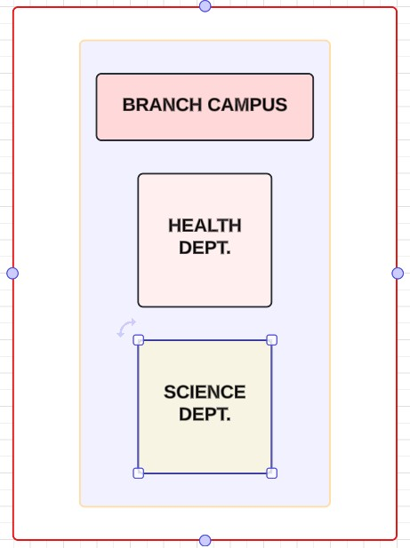

**MAIN CAMPUS**

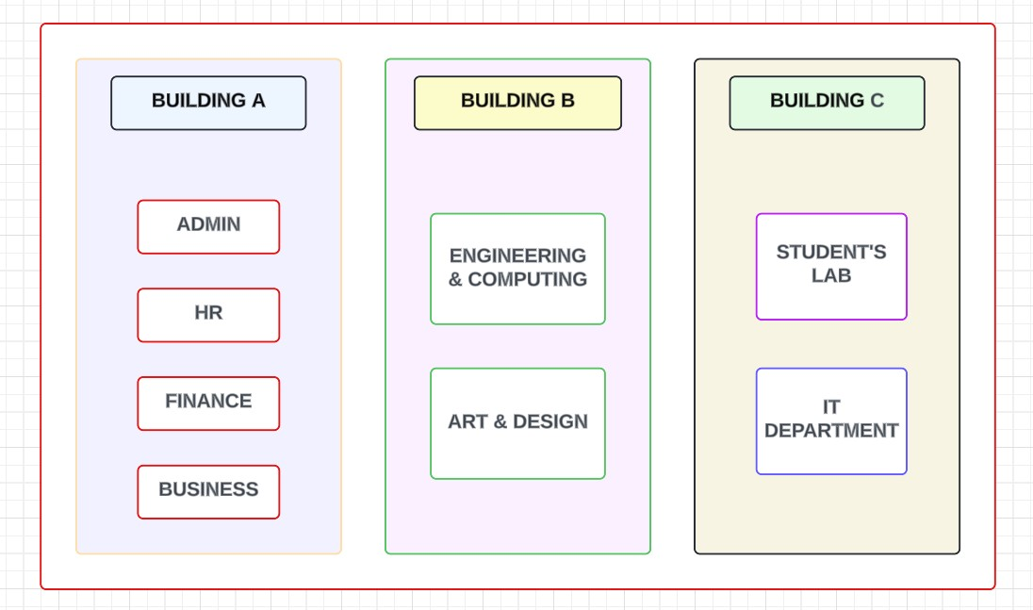

**Devices Used**

|  |  |
| --- | --- |
| **DEVICES** | **QUANTITY** |
| 1.Router | 3 |
| 2.Switch | 12 |
| 3.PCs | 10 |
| 4.Printer | 10 |
| 5.Email Server | 1 |
| 6.PT-FTP Server | 1 |
| 7.PT-WEB Server | 1 |

**Implementation**

To design the wired network of the university we initially started by placing the core devices into the frame as mentioned in the layout.

The whole network topology is connected in 3 layers

**1.Core layer:** The core layer is thebackbone of the network. It provides a high-speed connection between different distribution layer devices. The distribution layer connects the access layer to the core layer. The access layer provides initial connections to end users.

**2.Distribution layer:** The distribution layer in a computer network is the second layer of a three-layer hierarchical model. It acts as a boundary between the access layer and the core layer, and is responsible for routing, filtering, and quality of service (QoS) policies for the entire network

**3.Access Layer:** The access layer is the first layer of the Cisco threelayer hierarchical model. This layer allows end users to access the network. This layer also connects user-devices such as  [PCs,](https://www.computernetworkingnotes.com/ccna-study-guide/access-distribution-and-core-layers-explained.html) IP phones, wireless access points, printers, and scanners to the network.

User-devices connected to this layer use different protocols to discover each other, remove loops, and exchange data. End users access the network through this layer. Various services and security policies are also configured and enforced at this layer.

**Steps:**

* Firstly, we placed the router (MAIN-CAMPUS-ROUTER) at the center of the campus outline, which was further connected to the main campus switch through gigabit line.

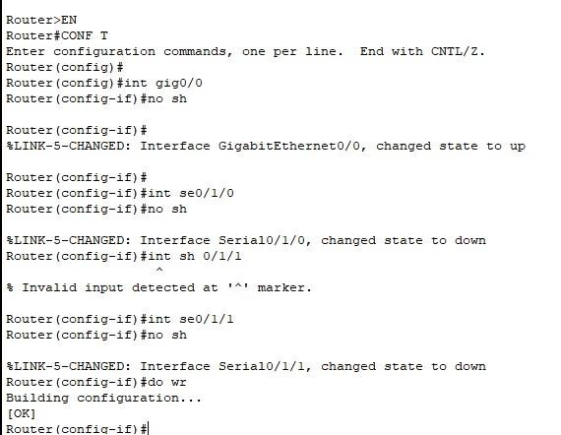

* The MAIN CAMPUS ROUTER is connected to the CLOUD ROUTER through the serial line cable

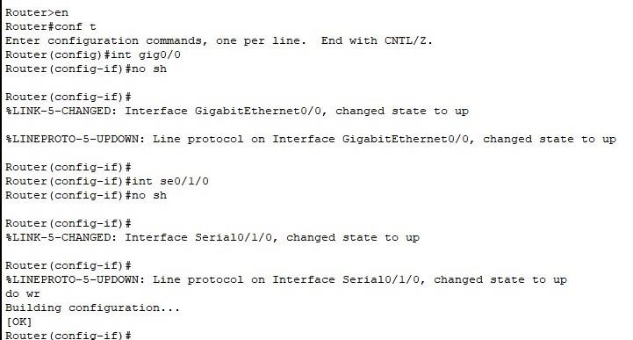

* The MAIN CAMPUS ROUTER is connected to the BRANCH CAMPUS

ROUTER through the serial line cable

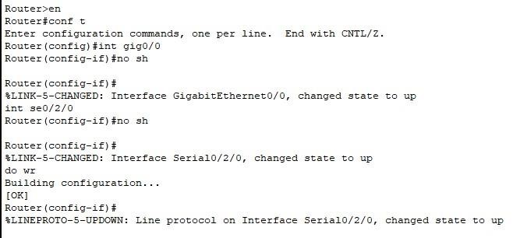

* Enabling the main campus switch (means giving the power supply)

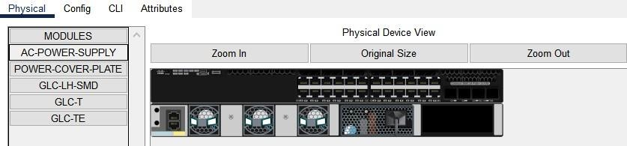

* Further the main campus switch (LAYER 3) is connected to the switch (LAYER 2) of each section like HR, Business and more using ethernet wire

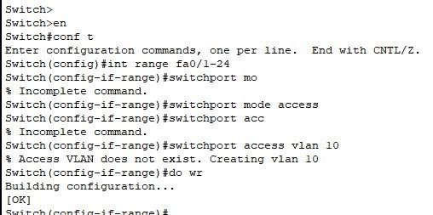

* The MAIN CAMPUS ROUTER which is connected to BRANCH ROUTER which is further connected to BRANCH (layer 3) switch and this switch is further connected to layer 2 switch which is connected to the PCs and printers of staff and student lab section using the ethernet cable

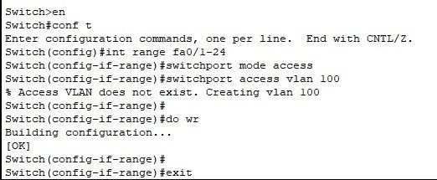

* Branch Campus LAYER 3 switch trunk configuration with BRANCH

ROUTER

o (**Network switch trunking**, often referred to as port trunking, link aggregation, or Ethernet bonding, is a technique employed to combine multiple physical links into a single logical link. This process not only enhances the bandwidth but also provides redundancy, fault tolerance, and load balancing capabilities.)

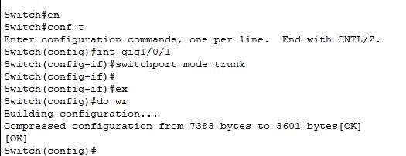

* Branch Campus LAYER 3 switch VLAN configuration

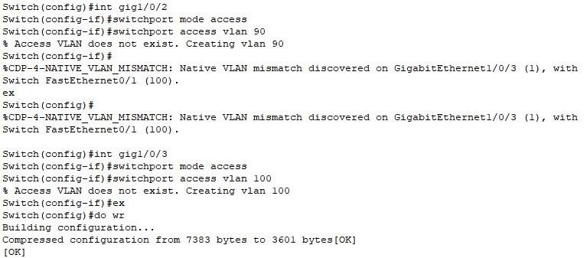

* The switch of each section is connected to one PC and a printer, while the switch of IT Dept connected to a PC, a web server and an FTP server

* Main Campus Router IP Configuration

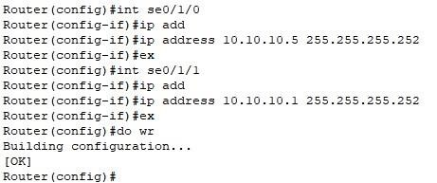

* Branch Campus Router IP Configuration

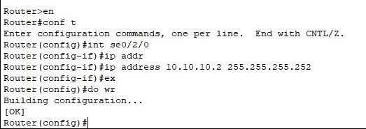

* Cloud Router IP Configuration

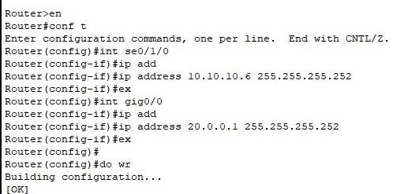

* Cloud Server IP Configuration

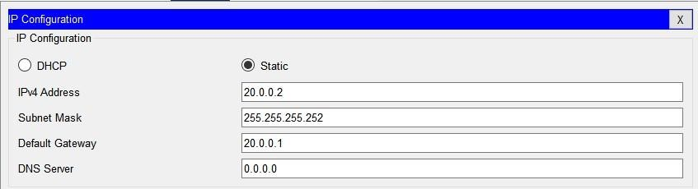

**Internal Routing:** Routers refer to internal routing tables to make decisions about how to route packets along network paths. A routing table records the paths that packets should take to reach every destination that the router is responsible for.

* Branch Campus Internal Routing

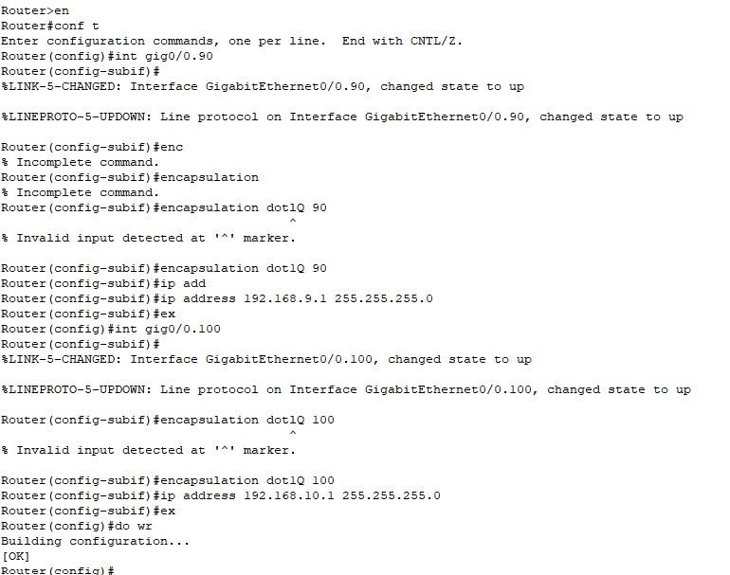

**What is DHCP (Dynamic Host Configuration Protocol)?**

* DHCP (Dynamic Host Configuration Protocol) is a network management protocol used to dynamically assign an IP address to any device, or [node,](https://www.techtarget.com/searchnetworking/definition/node) on a network so it can communicate using IP. DHCP automates and centrally manages these configurations rather than requiring network administrators to manually assign IP addresses to all network devices. DHCP can be implemented on small local networks, as well as large enterprise networks.

* DHCP assigns new IP addresses in each location when devices are moved from place to place, which means network administrators do not have to manually configure each device with a valid IP address or reconfigure the device with a new IP address if it moves to a new location on the network.

* DHCP IP Configuration in Branch Router

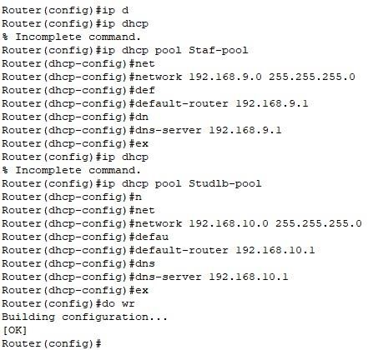

* DHCP Routing in Main Campus Network

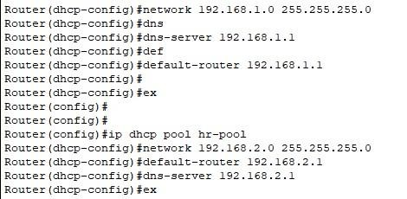

**Routing Protocol**: RIP (Routing Information Protocol) is a distancevector routing protocol that is used to determine the best path for forwarding packets in a network. It is a widely used protocol in local area networks (LANs) and wide area networks (WANs). RIP is a simple protocol that is easy to implement and manage, making it a popular choice for many network administrators.

* Implementation of RIP Protocol on Branch Router

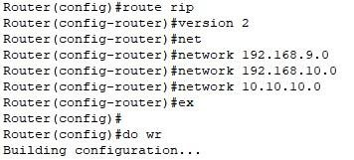

Implementation of RIP Protocol on Main Router

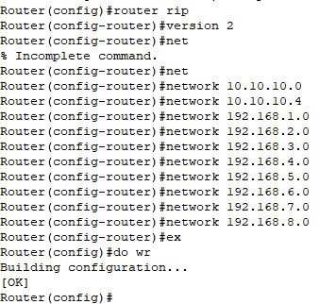

* Implementation of RIP Protocol on Cloud Router

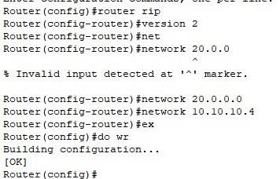

**Finally**

* *Building A & B (Main Campus Topology):*

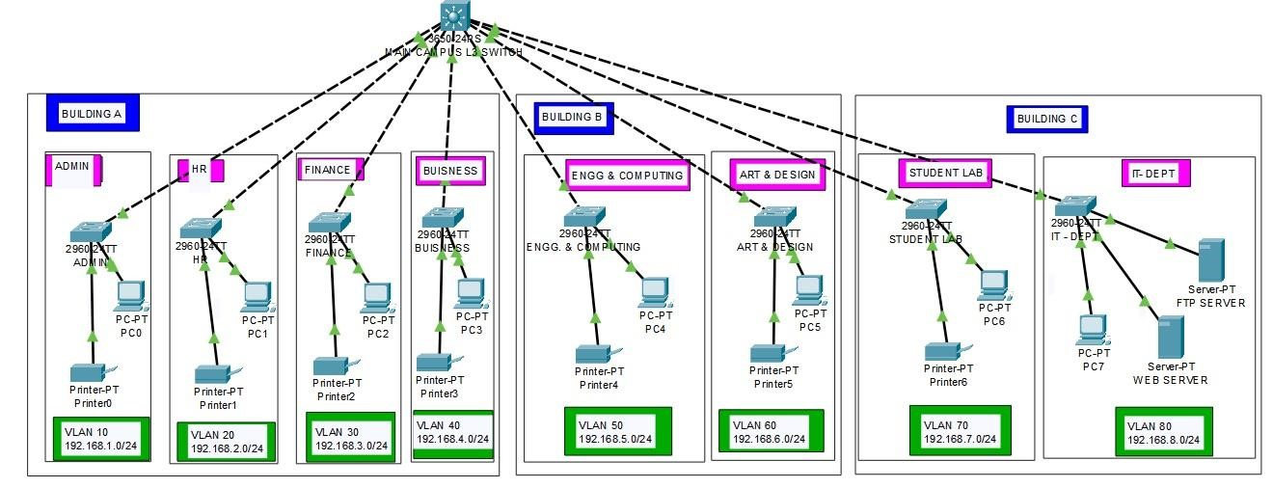

* *Building C (Branch Campus Topology):*

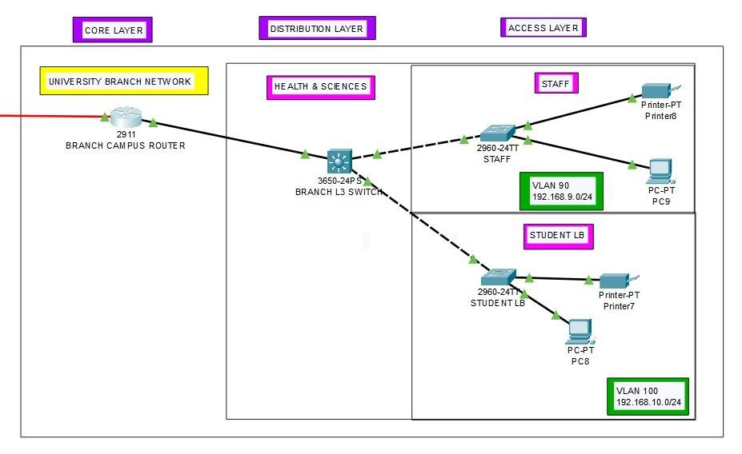

*Cloud Server Topology:*

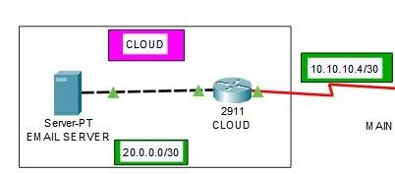

* *RESULT:* Finally, we have combined all the steps as mentioned above and implemented the desired wireless network for the whole campus

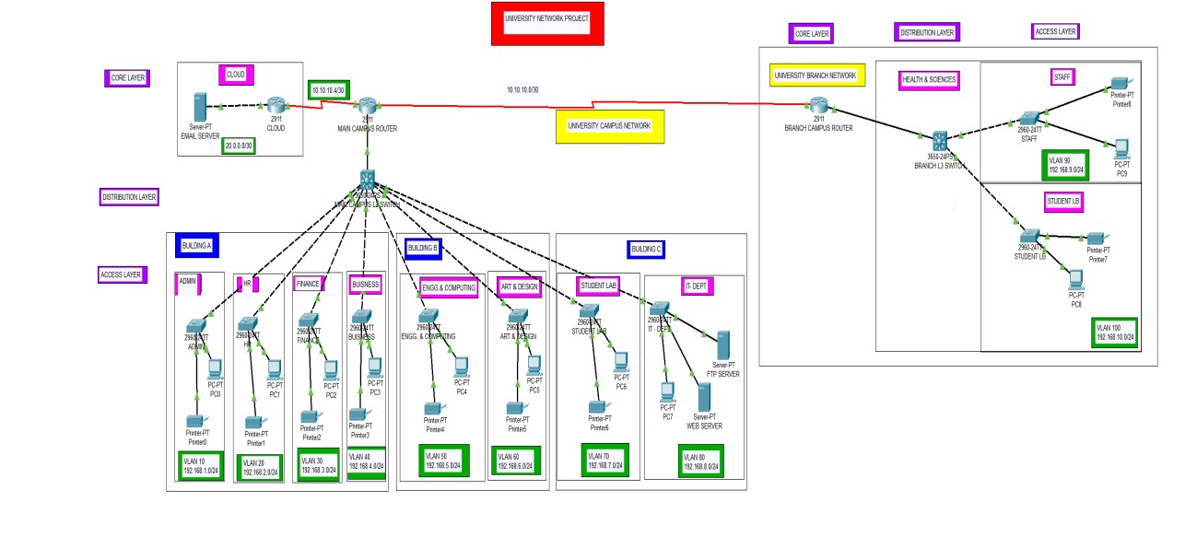

* **Ping Test:** Network connectivity and communication can be tested using the ping command, followed by the domain name or the IP

address of the device (equipment) whose connectivity one wishes to verify

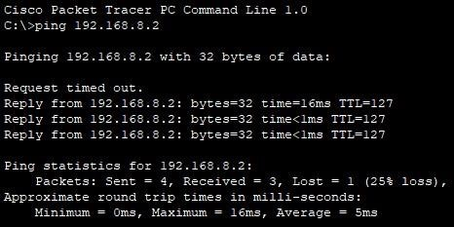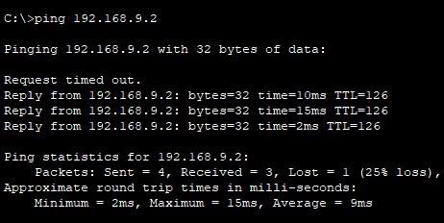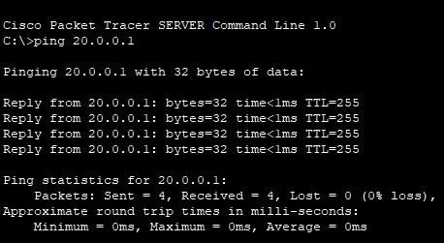

**Conclusion:**

The network infrastructure consists of three routers serving as the backbone, facilitating communication between different segments of the network. These routers likely connect various departments, buildings, or floors within the campus.

Within each segment, there are **10** computers and **10** printers, suggesting a balanced distribution of resources across the network. The computers serve as endpoints for users to access information and applications, while the printers provide printing services to users within each segment.

Additionally, there are various other devices connected to the network, which could include switches, access points, servers, and possibly IoT devices depending on the specific requirements and scope of the project.

Overall, the network design aims to provide reliable connectivity and efficient data transfer within the campus environment, catering to the diverse needs of students, faculty, and staff. It likely incorporates security measures such as firewalls, access controls, and network segmentation to safeguard sensitive data and ensure the integrity of the network.